

**Advanced Software Engineering**

Course # CSEE 5551 0001

Semester: Spring 2017

LAB Assignment # 7

Submission Date: 3/8/2017

Student Name: Satya Sai Deepthi Katta

Student ID: 16231371

**Instructor:** Dr. Yugyung Lee

**Email:** LeeYu@umkc.edu

**Department of Computer Science & Electrical Engineering**

**University of Missouri, Kansas City**

**Welcome to Lab Assignment #7 Wiki Page!**

Submission on 3/8/17

**Abstract:**

The main objective of this assignment is to provide an overview on creating an Ionic FrameWork Application. This application is created using Brackets software which involves the home page having mashup with two web services. Also a mobile application is created with good UI and the wireframes are created using creately.com. Test cases are created for the application.

**TASK: Create WireFrames for Ionic FrameWork Application.**

**To present the rough view of the Ionic Framework Application, Wireframes are created using online web service called creately.com. The web Application layouts are presented.**

**Below provided are the screenshots for Wireframes of the Ionic Framework Application.**

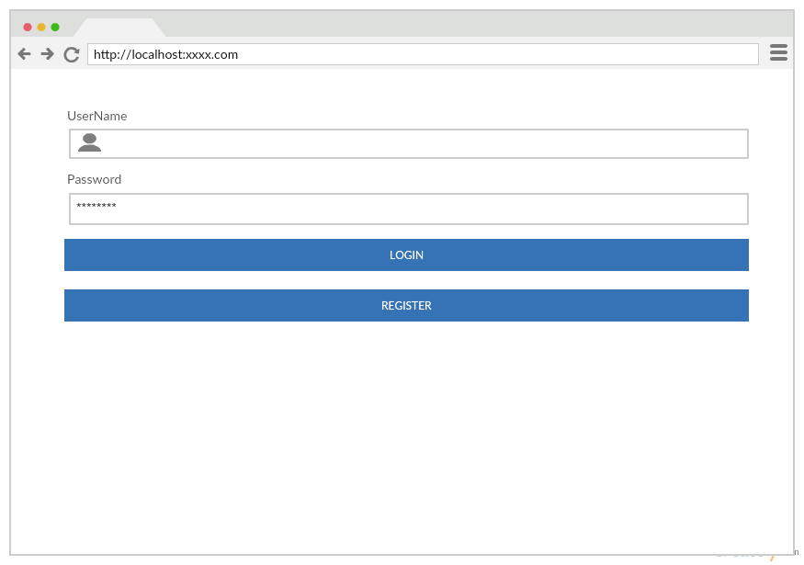

**Fig 1. Wireframe for Login Page of the Application.**

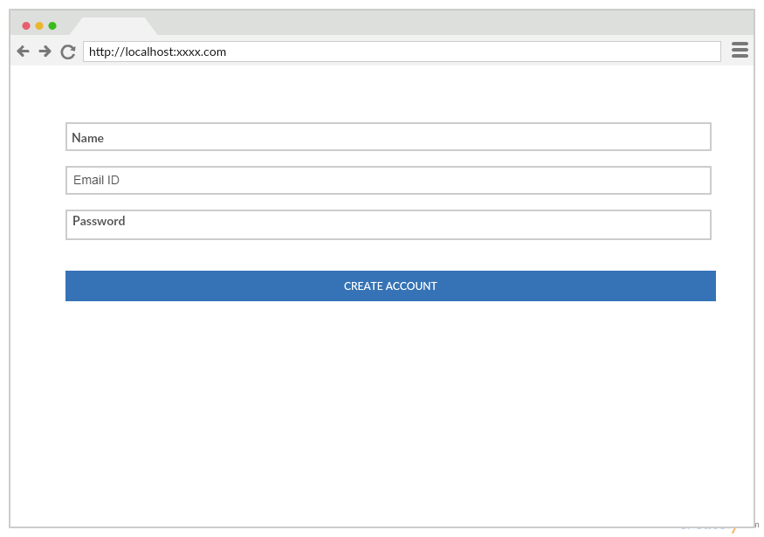

**Fig 2. Wireframe for Registration Page of the Application.**

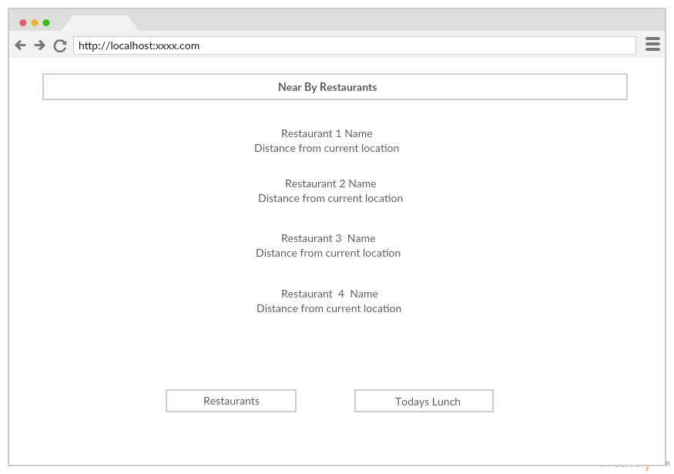

**Fig 3. Wireframe for Restaurants Details of the Ionic Framework Application.**

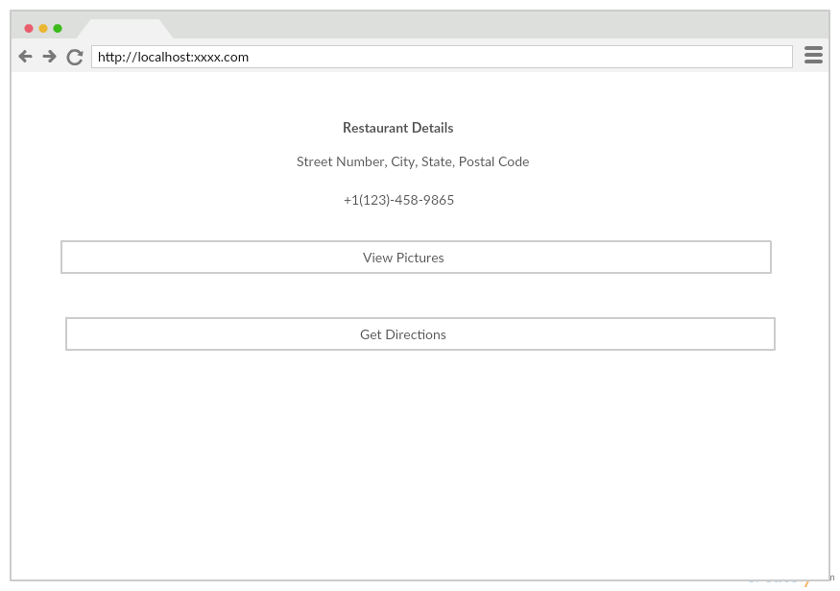

**Fig 4. Wireframe for Single Restaurant details showing picture and directions options.**

**TASK 1: Create an Ionic FrameWork Application.**

An Ionic Framework Application is created using Brackets Software. A basic login page consisting of Login and Register buttons. On clicking Login, the application is navigated to home page. On clicking Register, the application opens a register page which takes the details of a new user.

On launching the Application, the first screen is the login page

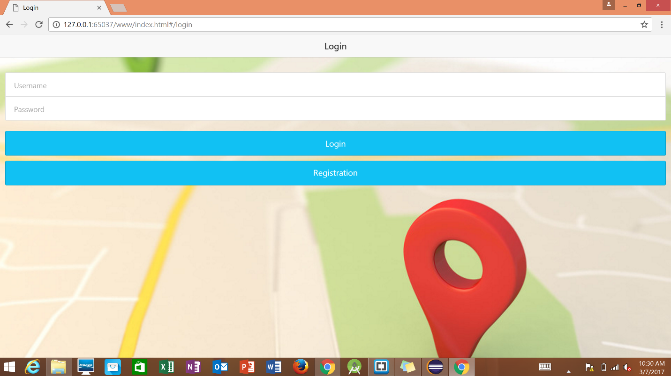

Fig 5. Login Page displayed after opening the application.

Initially, any new user must register into the application by adding their email address and setting up a password.

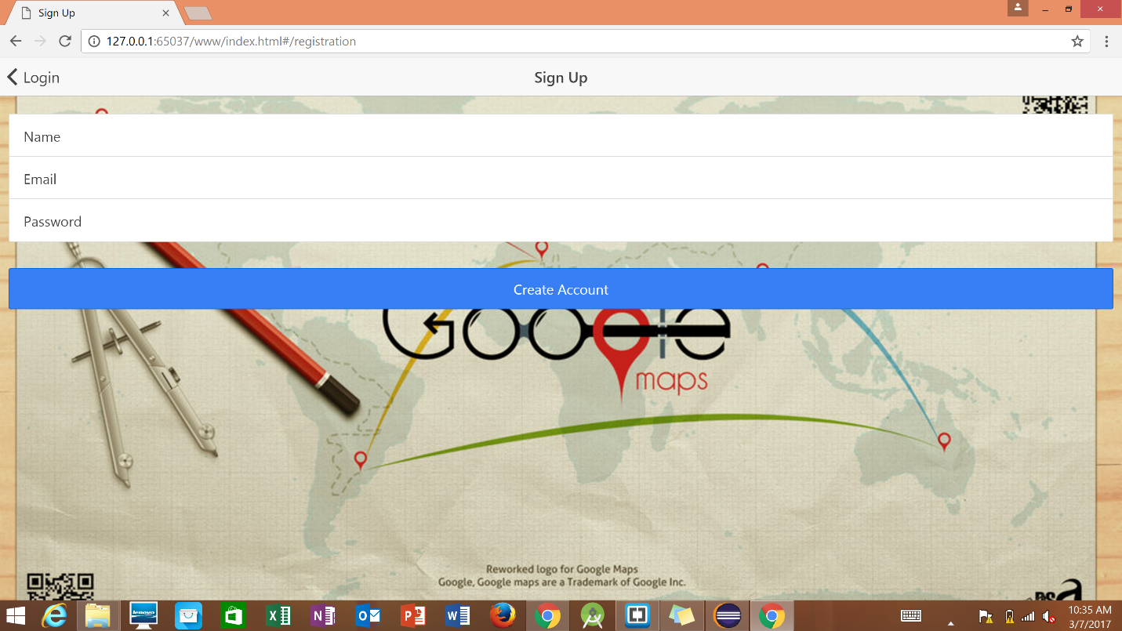

**Fig 6. Registration Page of the Web Application.**

**A user account is created for ‘Admin’. The username and password are set inbuilt in the application as “Admin”. On clicking Create Account, a new account is created.**

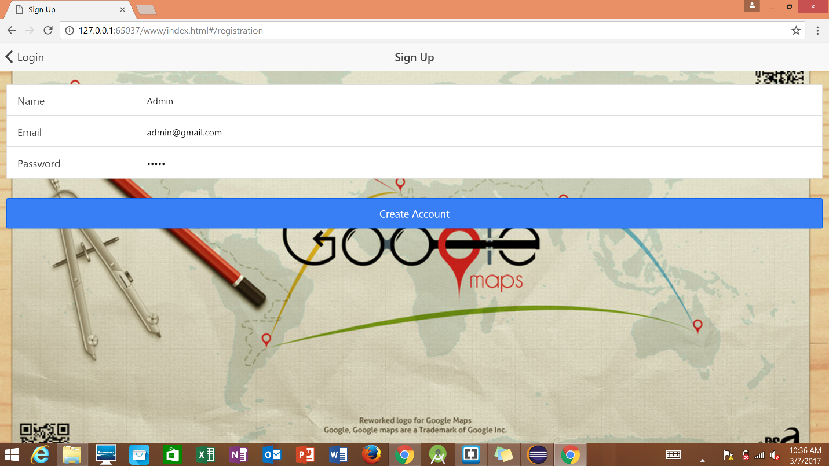

**Fig 7. Admin registration in the Web Application.**

Entering the correct credentials, login will move to home page. If credentials are incorrect then a error message pops up showing ‘Invalid Credentials’.

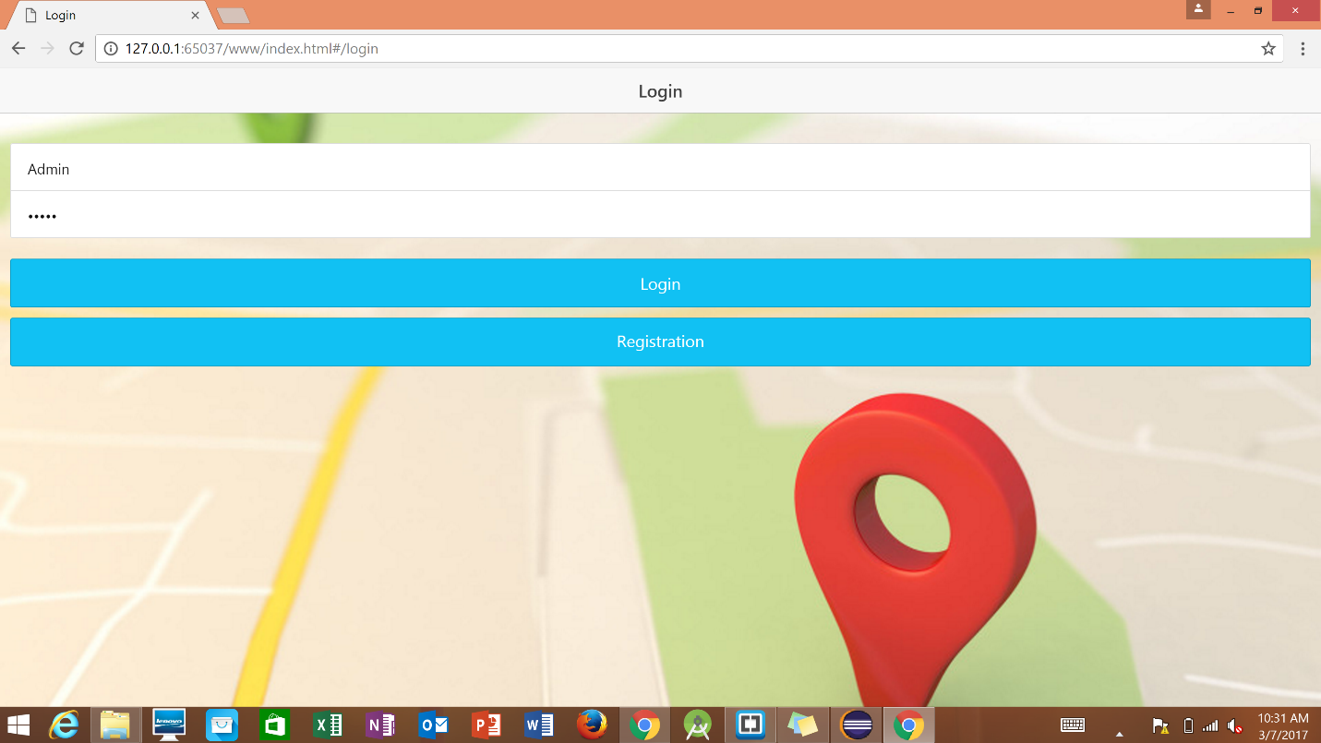

Fig 8. User Login into Web Application using Admin Credentials.

**TASK 2 : Home page should have a Mashup using at least Two Web Services**

After successful login into the account, the web application asks for the permission to allow the location of the device. By allowing location services, the current location is tracked using Googles Maps location API.

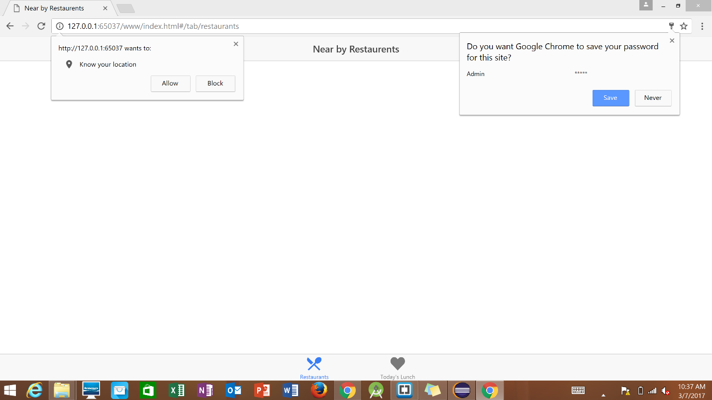

Fig 9. Location permission from the Local Host Website.

After allowing location permission, the application navigates to the list of restaurants near by. The details of the restaurants like restaurant name and the distance from the current location are also given in the list.

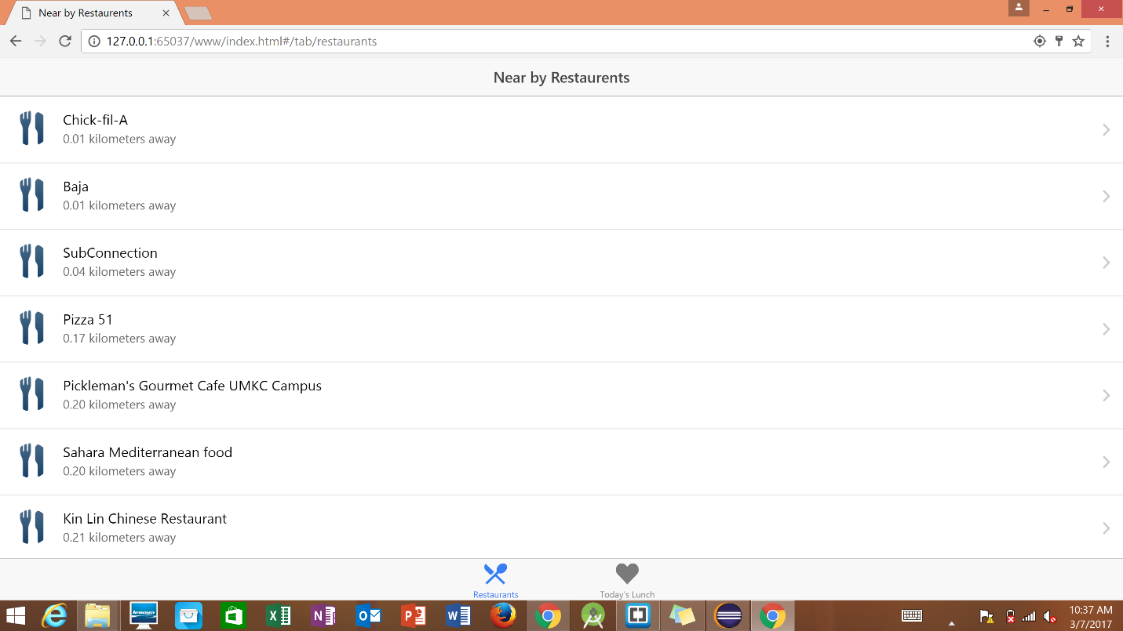

**Fig 10. List of Near By Restaurants displayed through Web Application.**

**On selecting a restaurant, further details of the restaurant like Address with postal code, phone number are displayed. Along with these, two options are displayed. ‘View photos’ shows the pictures of the food in the restaurant. By selecting ‘Get Directions’ gets the directions from the current location to the restaurant using Google Maps API.**

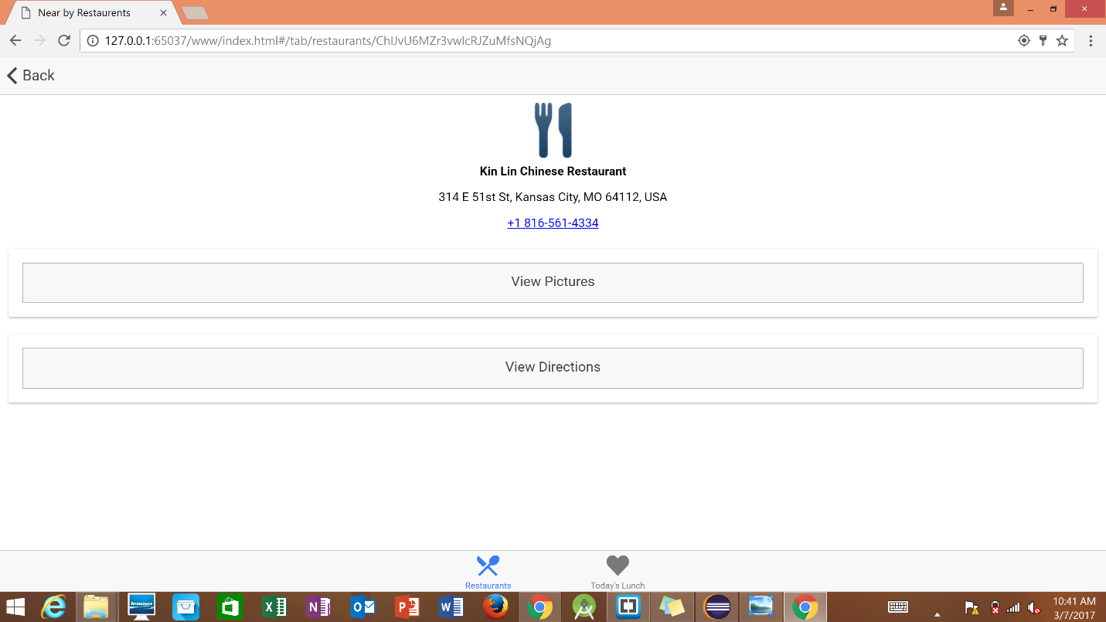

**Fig 11. Details of the selected restaurant from the List of near by restaurants.**

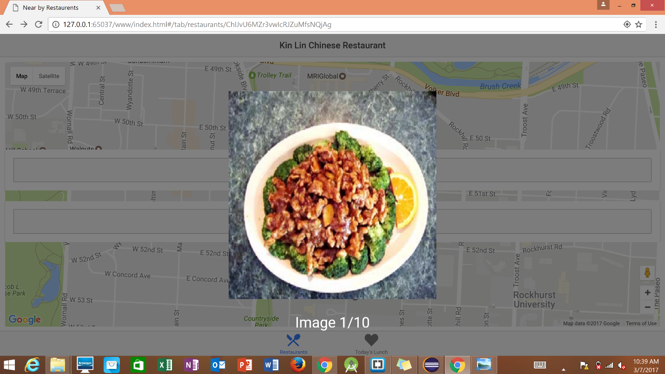

**Fig 12. Displaying photos of food from the restaurant.**

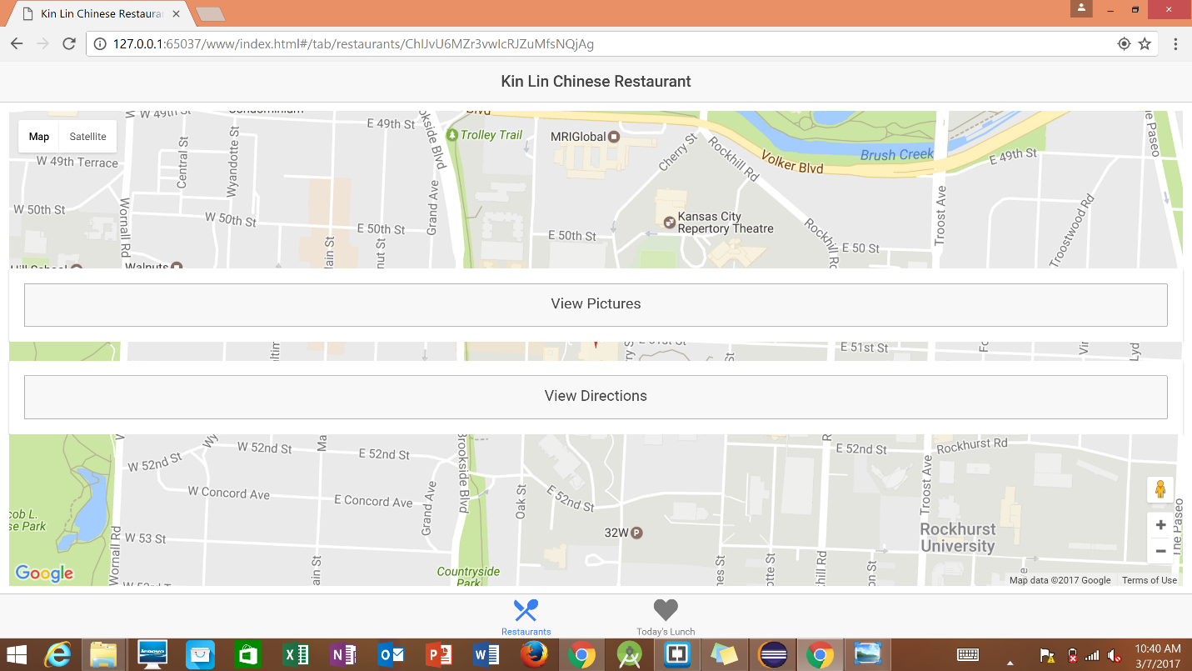

**Fig 13. Locating the current location in the map.**

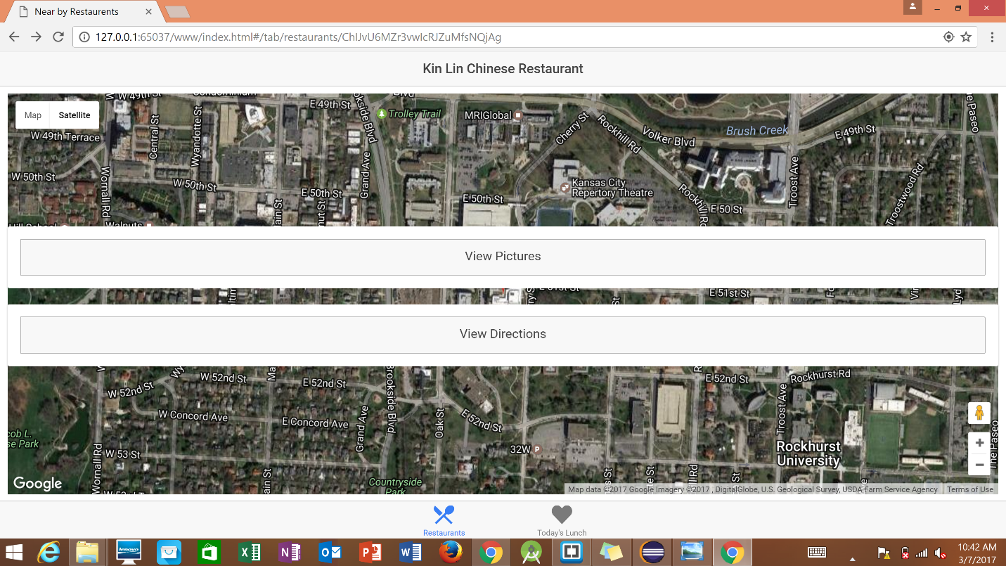

**Fig 14. Satellite View of the Current location in Google Maps.**

**TASK 3: Create a Mobile Application related to your project**

**Mobile Application is created for the Ionic Framework Application. The screenshots are given below for the mobile application which is run on a android emulator.**

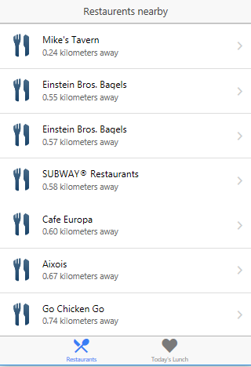

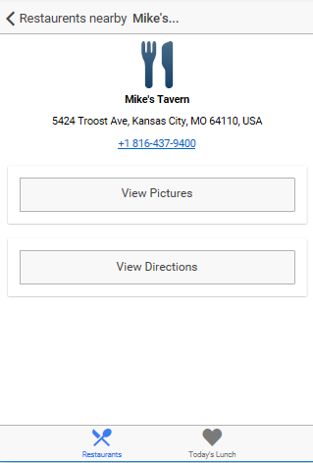

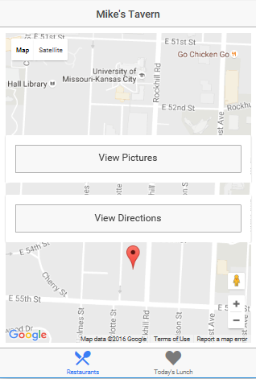

**TASK 4: Write at least 3 Unit Test Cases related to your application.**

|  |  |  |  |  |
| --- | --- | --- | --- | --- |
| **S.No** | **Test Case Title** | **Description** | **Expected Result** | **Actual Result** |
| 1. | Successful Login | User logs in using the correct login credentials. User should be redirected to home page | Successful login | Success |
| 2. | User Registration | Clicking on register button in login page must redirect to register page | Register page should be displayed | Success |
| 3. | Distance Calculation | The distance to the restaurant is calculated from the current location | Distance is displayed below the restaurant name in the list of nearby restaurants. | Success |
| 4. | Photos Displayed | By clicking View Photos, the pictures from the google database are displayed. | Images of the food are displayed. | Success |

**Using YSlow Add-on in chrome, the web application got a Grade C.**

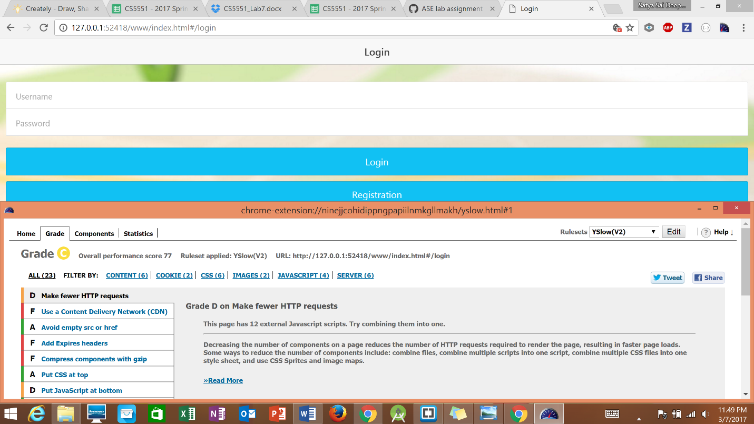

**Fig 15. Testing the Application using YSlow Tool.**

**References:**

<https://developers.google.com/maps/documentation/business/>

<http://ionicframework.com/docs/>

<https://developers.google.com/places/>

<https://developers.google.com/maps/>